1. Demonstrate your circuit to the instructor or lab assistant and attach a photo of the circuit to your lab report.

✓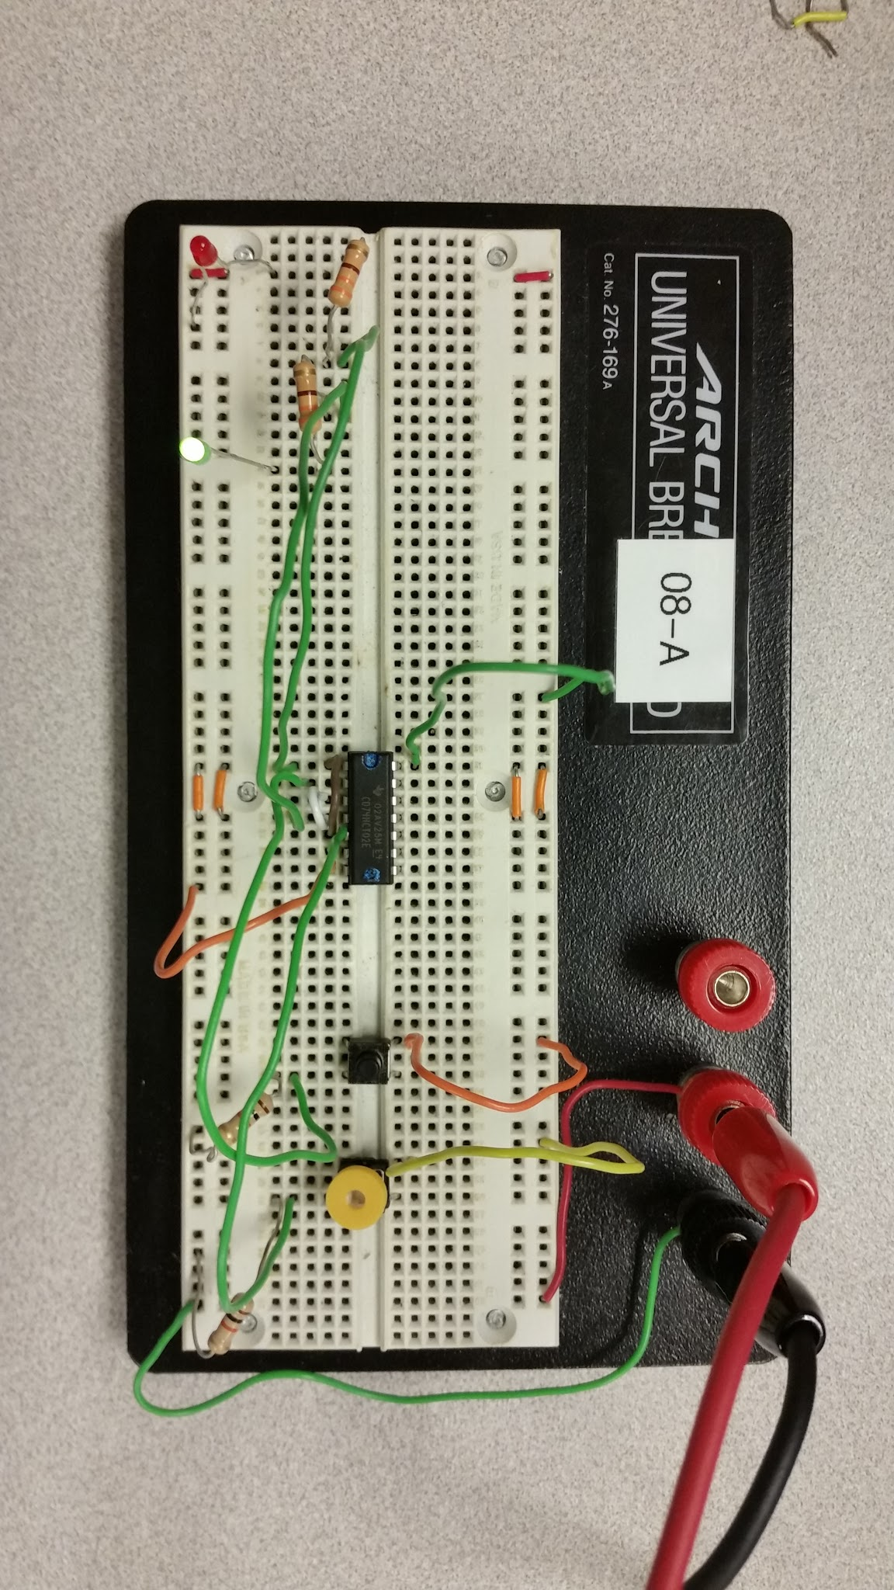

1. Notice that, unlike the combinatorial circuits we've discussed in class, the output of the S-R latch depends on both the inputs, and the current state of the device. A *characteristic table* is used to specify the output of the device in terms of both its input and current state. Determine, by observing the state of the LEDs, the characteristic table of the device.

|  |  |  |  |  |
| --- | --- | --- | --- | --- |
| **R** | **S** | **previous Q** | **New Q** | **New Q'** |
| 0 | 0 | 0 | 0 | 1 |
| 0 | 0 | 1 | 1 | 0 |
| 0 | 1 | 0 | 1 | 0 |
| 0 | 1 | 1 | 1 | 0 |
| 1 | 0 | 0 | 0 | 1 |
| 1 | 0 | 1 | 0 | 1 |
| 1 | 1 | 0 | 0 | 0 |
| 1 | 1 | 1 | 0 | 0 |

1. What happens to Q and Q' when both inputs are set to logic 1?
   1. Output is 0
2. Explain how the circuit produces the observed result. (In other words write a couple paragraphs explaining why the output of this circuit makes sense given the defined behavior of its component gates when R=1 and S=1.)
   1. Since R and S input NOR gates, if either of the two signals are 1, the output will be 0. This is due to the nature of the NOR gate that produces a 0 if any of its inputs are 1. Therefore, $Q$ and $\underline{Q}$ are always 0 if R and S are both 1.
3. The book claims that setting both inputs to 1 produces an "indeterminate" result. Describe a specific sequence of input values for R and S that could lead to Q being in an indeterminate (or random), but stable, state. (Hint: Consider what happens when R and S both change values "simultaneously".) Describe the random state and the cause of the randomness. I'm going to be very particular about how this questions is written. You will probably want to have another group read your answer to make sure it is clear. Note: I'm not looking for a description of any intermediate states. I'm only interested in final, stable, states.
   1. Because both S and R are being hit at the same time, it places Q into a flux waiting for either S or R to change and get an input so it can have a determined state. While it is in this state, the ambient static electricity is creating fluctuations and creating the indeterminant results.
4. This first diagram shows a typical clocked usage of the flip flop. Note that, for this diagram, PR and CLR are always 1.

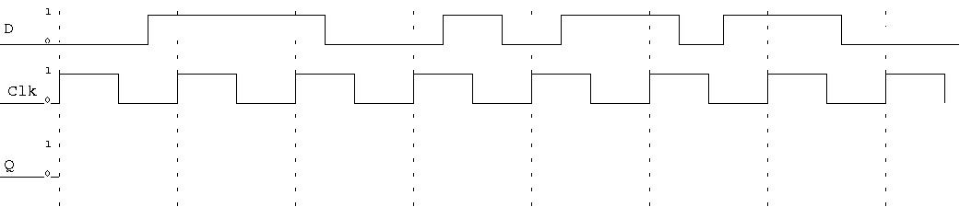

1. This diagram shows typical preset / clear behavior. Note that the clock remains at 0 for the first half of the diagram.

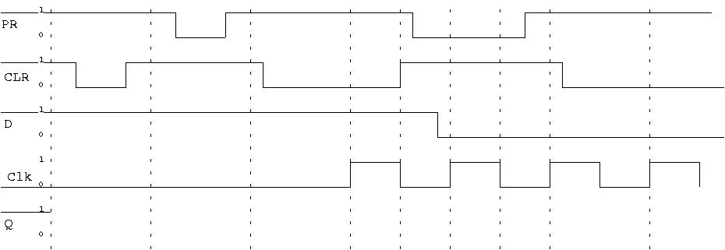

1. This diagram shows what happens when preset and clear are both low at the same time. The results of setting preset and clear to low at the same time are not defined, so the behavior may not be consistent.

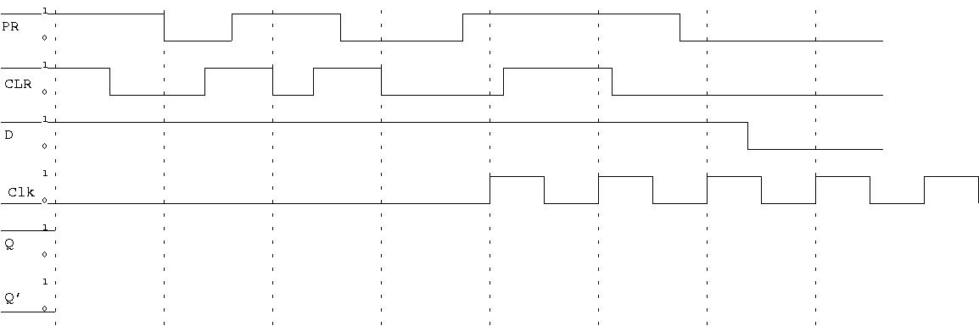

1. Report your observations using a characteristic table.

|  |  |  |  |  |
| --- | --- | --- | --- | --- |
| Logic1 | A0 | A1 | A1 | A0 |
| 0 | 0 | 0 | 0 | 0 |
| 0 | 0 | 1 | 1 | 0 |
| 0 | 1 | 0 | 1 | 0 |
| 0 | 1 | 1 | 0 | 0 |
| 1 | 0 | 0 | 0 | 1 |
| 1 | 0 | 1 | 1 | 1 |
| 1 | 1 | 0 | 1 | 0 |
| 1 | 1 | 1 | 0 | 0 |

1. Based on your observations, what useful circuit have you constructed? Hint: Make sure your LED for A1 is to the left of the LED for A0.

This could be used as a simple adder, or for processes that have 4 step sequences.

1. Demonstrate your circuit to the instructor or lab assistant and attach a photo of the circuit to your lab report.

✓